**Week 6 :**

**Exercise 1 :**Skill : React

After installing nodejs :  
node -v

npm -v

Install Create React App :  
npm install -g create-react-app

Create a React Application :

npx create-react-app myfirstreact

Navigate into the project folder :  
cd myfirstreact

Open in Visual Studio Code :  
code .

App.js :  
import React from 'react';

function App() {

return (

<div>

<h1>Welcome to the first session of React</h1>

</div>

);

}

export default App;

Start the Application :

npm start

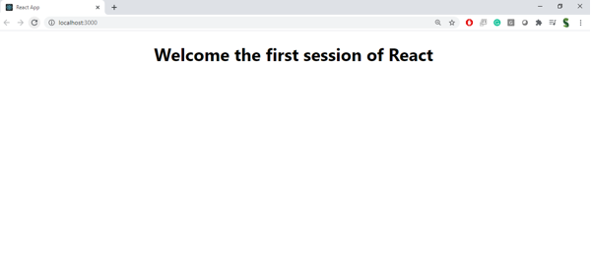

**Exercise 2 :**

Create React App :  
npx create-react-app StudentApp

Create "Components" Folder Inside src/ :  
Components

Create Home.js inside Components :  
// src/Components/Home.js

import React, { Component } from 'react';

class Home extends Component {

render() {

return (

<div>

<h1>Welcome to the Home page of Student Management Portal</h1>

</div>

);

}

}

export default Home;

Create About.js inside Components :

// src/Components/About.js

import React, { Component } from 'react';

class About extends Component {

render() {

return (

<div>

<h1>Welcome to the About page of the Student Management Portal</h1>

</div>

);

}

}

export default About;

Create Contact.js inside Components :

// src/Components/Contact.js

import React, { Component } from 'react';

class Contact extends Component {

render() {

return (

<div>

<h1>Welcome to the Contact page of the Student Management Portal</h1>

</div>

);

}

}

export default Contact;

Edit App.js to Use All Components :

// src/App.js

import React from 'react';

import Home from './Components/Home';

import About from './Components/About';

import Contact from './Components/Contact';

function App() {

return (

<div className="App">

<Home />

<About />

<Contact />

</div>

);

}

export default App;

Run the Application :

npm start

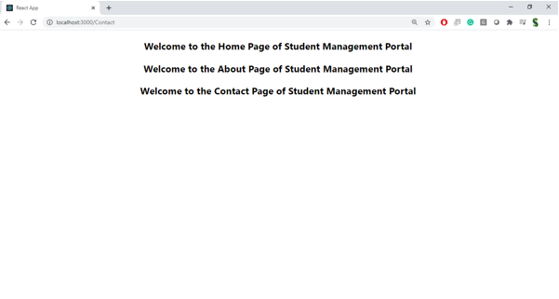

**Exercise 3 :**

Create React App :  
npx create-react-app scorecalculatorapp

cd scorecalculatorapp

Create Components/CalculateScore.js :

import React from 'react';

import '../Stylesheets/mystyle.css';

function CalculateScore() {

const student = {

name: "Harshitha",

school: "ABC Public School",

totalMarks: 450,

goal: 500

};

const average = (student.totalMarks / student.goal) * 100;

return (

<div className="score-container">

<h2>Student Score Report</h2>

<p><strong>Name:</strong> {student.name}</p>

<p><strong>School:</strong> {student.school}</p>

<p><strong>Total Marks:</strong> {student.totalMarks}</p>

<p><strong>Goal:</strong> {student.goal}</p>

<p className="highlight"><strong>Average Score:</strong> {average.toFixed(2)}%</p>

</div>

);

}

export default CalculateScore;

Create Stylesheets/mystyle.css :

.score-container {

background-color: #f0f8ff;

padding: 20px;

border: 2px solid #007bff;

border-radius: 10px;

width: 400px;

margin: 30px auto;

box-shadow: 0 4px 8px rgba(0, 0, 0, 0.2);

font-family: Arial, sans-serif;

}

.score-container h2 {

text-align: center;

color: #333;

}

.score-container p {

font-size: 16px;

margin: 8px 0;

}

.highlight {

color: green;

font-weight: bold;

}

Edit App.js to Call CalculateScore :

import React from 'react';

import './App.css';

import CalculateScore from './Components/CalculateScore';

function App() {

return (

<div className="App">

<CalculateScore />

</div>

);

}

export default App;

Run Your App :

npm start

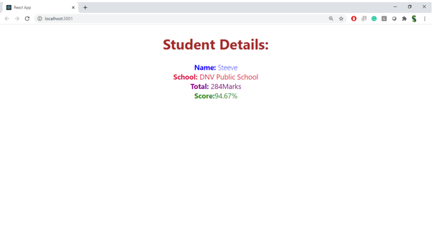

**Exercise 4 :**Create the React App :  
npx create-react-app blogapp

cd blogapp

Post.js – Post class :

// src/Post.js

import React from 'react';

class Post extends React.Component {

render() {

return (

<div className="post">

<h2>{this.props.title}</h2>

<p>{this.props.body}</p>

</div>

);

}

}

export default Post;

Posts.js – Main Component :

// src/Posts.js

import React from 'react';

import Post from './Post';

class Posts extends React.Component {

constructor(props) {

super(props);

this.state = {

posts: [],

hasError: false,

};

}

loadPosts() {

fetch('https://jsonplaceholder.typicode.com/posts')

.then((response) => response.json())

.then((data) => {

this.setState({ posts: data.slice(0, 5) }); // Only load first 5 posts

})

.catch((error) => {

console.error('Error fetching posts:', error);

this.setState({ hasError: true });

});

}

componentDidMount() {

this.loadPosts();

}

componentDidCatch(error, info) {

alert('Something went wrong in Posts component.');

console.log('Error caught:', error, info);

this.setState({ hasError: true });

}

render() {

if (this.state.hasError) {

return <h1>Error loading posts!</h1>;

}

return (

<div>

<h1>Latest Blog Posts</h1>

{this.state.posts.map((post) => (

<Post key={post.id} title={post.title} body={post.body} />

))}

</div>

);

}

}

export default Posts;

Modify App.js to Render Posts :

// src/App.js

import React from 'react';

import './App.css';

import Posts from './Posts';

function App() {

return (

<div className="App">

<Posts />

</div>

);

}

export default App;

Start the App :

npm start

**Exercise 5 :**// File: src/components/CohortDetails.js

import React from "react";

import styles from "./CohortDetails.module.css";

const CohortDetails = ({ name, status, startDate, endDate }) => {

const headingStyle = {

color: status.toLowerCase() === "ongoing" ? "green" : "blue"

};

return (

<div className={styles.box}>

<h3 style={headingStyle}>{name}</h3>

<dl>

<dt>Status:</dt>

<dd>{status}</dd>

<dt>Start Date:</dt>

<dd>{startDate}</dd>

<dt>End Date:</dt>

<dd>{endDate}</dd>

</dl>

</div>

);

};

export default CohortDetails;

// File: src/components/CohortDetails.module.css

.box {

width: 300px;

display: inline-block;

margin: 10px;

padding: 10px 20px;

border: 1px solid black;

border-radius: 10px;

}

dt {

font-weight: 500;

}

// File: src/App.js

import React from "react";

import CohortDetails from "./components/CohortDetails";

function App() {

return (

<div>

<h2>Cohort Dashboard</h2>

<CohortDetails

name="React Bootcamp"

status="Ongoing"

startDate="2025-06-01"

endDate="2025-07-31"

/>

<CohortDetails

name="Java Fundamentals"

status="Completed"

startDate="2025-04-01"

endDate="2025-05-15"

/>

</div>

);

}

export default App;

src/components/CohortDetails.js :

import React from "react";

import styles from "./CohortDetails.module.css";

const CohortDetails = ({ name, status, startDate, endDate }) => {

const headingStyle = {

color: status.toLowerCase() === "ongoing" ? "green" : "blue"

};

return (

<div className={styles.box}>

<h3 style={headingStyle}>{name}</h3>

<dl>

<dt>Status:</dt>

<dd>{status}</dd>

<dt>Start Date:</dt>

<dd>{startDate}</dd>

<dt>End Date:</dt>

<dd>{endDate}</dd>

</dl>

</div>

);

};

export default CohortDetails;

src/components/CohortDetails.module.css :

.box {

width: 300px;

display: inline-block;

margin: 10px;

padding: 10px 20px;

border: 1px solid black;

border-radius: 10px;

}

dt {

font-weight: 500;

}

src/App.js :

import React from "react";

import CohortDetails from "./components/CohortDetails";

function App() {

return (

<div>

<h2>Cohort Dashboard</h2>

<CohortDetails

name="React Bootcamp"

status="Ongoing"

startDate="2025-06-01"

endDate="2025-07-31"

/>

<CohortDetails

name="Java Fundamentals"

status="Completed"

startDate="2025-04-01"

endDate="2025-05-15"

/>

</div>

);

}

export default App;

Commands to Setup :

cd your-project

npm install

npm start

OUTPUT :  
Cohort Dashboard

React Bootcamp

Status: Ongoing

Start Date: 2025-06-01

End Date: 2025-07-31

Java Fundamentals

Status: Completed

Start Date: 2025-04-01

End Date: 2025-05-15